Code Review: Ixxxxxxx
Reviewer: Developer
Date: Month day, year

Bugs

Preventative Action/Safety
- I’m not totally sure how Typed Datasets work, but I assume it’s possible for a datatable within the typed dataset to be Nothing.
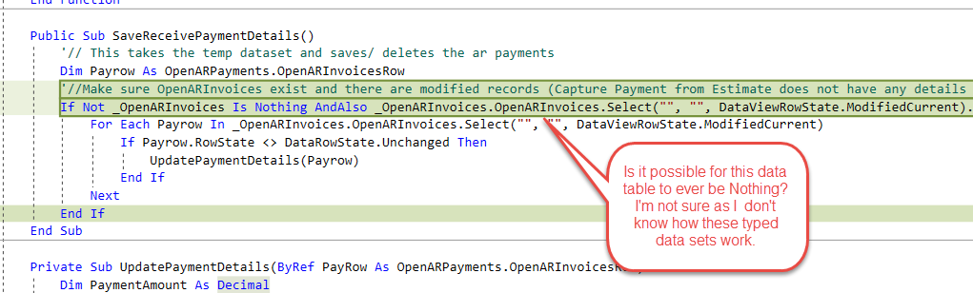
It might not be a plausible situation for this method where the Dataset(_OpenARInvoices) is something and the OpenARInvoices datatable is nothing, but probably still worth a check.
We can do this check easily enough with the null-conditional operator(?). If you’re aware of this already, you can ignore the rest.
In the first part of the conditional we can add this check.
If Not _OpenARInvoices?.OpenARInvoices Is Nothing AndAlso … Then
The (?) will stop the object member access at any point where the member is Nothing, so you will not receive an Object not Initialized exception.
It might be a little cryptic but it helps reduce validation code, as you can string together any number of member accessors into one Is Nothing check.
If _MLB?.Teams?.BlueJays?.Players?.Pitchers() IsNot Nothing Then …
If any one of those objects is Nothing then the whole statement is False and will not throw an exception.
You can also use this when trying to set an object:
_jaysPitchers As List(of Pitchers) = MLB?.Teams?.BlueJays?.Players?.Pitchers()
The _jaysPitchers object will remain Nothing and no exception will be thrown.

Design/Architecture (Duplication, appropriate project, namespaces, maintainability)

Data Model (Naming, good design, needs index?)

Performance (Minimize DB hits, excessive loops, queries, scalable)

UI (Alignment, naming, standardization, tab order)

Error Handling (Behind events, appropriate parameter checking)

Cleanup (Dispose code, remove handlers, large data objects)

Readability (Well-named variables, methods, clear algorithm, is it understandable)
- Nit: We are trying to modernize the way we handle Nothing checks to be more inline with .Net standards. To that end we are trying to clean up uses of Not IsNothing(obj) as well as Not obj Is Nothing. The second is closer to what we want, but .Net has the IsNot operator.
If _OpenARInvoices IsNot Nothing AndAlso …
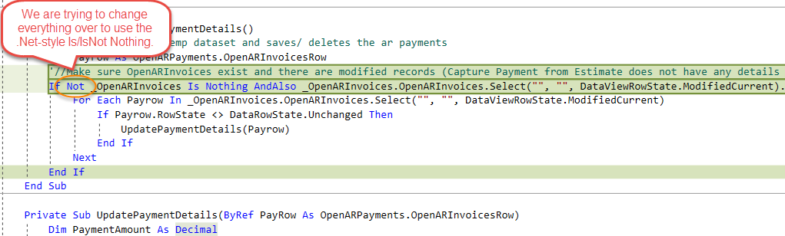
This recommendation comes straight from the top:
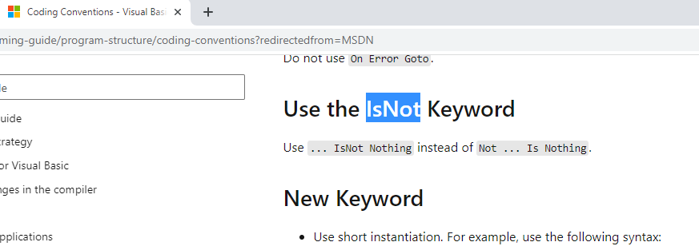

Comments (Useful, explains why rather than how)

Message Boxes (Grammar, spelling, captions, appropriate icons)

Ticket Management (Release Branch?, Testing Notes)

Extras

